--------------------------------------------------------------------------------------------------------------------------

Student name: Navjot Singh Virk, Student Number: x13112406

--------------------------------------------------------------------------------------------------------------------------

REPORT OF ANALYSIS

**Students Alcohol Consumption**

*DATASET 1: student-mat.csv*

(Mathematics Students)

*DATASET 2: student-por.csv*

(Portuguese Language Students)

Currently available at:

<https://archive.ics.uci.edu/ml/datasets/STUDENT+ALCOHOL+CONSUMPTION>

--------------------------------------------------------------------------------------------------------------------------

Table of Contents

Introduction 1

Formal Description of the Datasets 1

Objective of Analysis 3

Data Processing Activities Carried out 3

Final Analysis Results 3

Individual Analysis on Datasets (Results) 3

Weekend alcohol consumption based on if the student lives with their parents (mother or father) or other 3

Weekend Alcohol Consumption based on Gender 4

Weekend Alcohol based on age 5

Workday Alcohol Consumption 6

School Absences and Alcohol consumption 7

Weekend Alcohol Consumption based on gender (sex) 9

Workday Alcohol Consumption and Grades 10

Weekly Study Time 11

Combined Analysis (Results) 12

## Introduction

The aim this report is present analysis results based on a series of analyses carried out on Dataset 1 and Dataset 2 using R language and the programming environment RStudio.

## Formal Description of the Datasets

**DATASET 1**

The dataset 1 (student-mat.csv) used in this analysis is about Mathematics students in secondary school and contains 33 attributes which was composed by P.Cortez and A. Silva, at University of Minho in Portugal.

**DATASET 2**

The dataset 2 (student-por.csv) used in this analysis is about Portuguese subject students in secondary school and it also contains 33 attributes like Dataset 1 and is composed by the same author’s as Dataset 1.

Below are the attributes of datasets (both the datasets contains same attributes which will be helpful during the analysis and comparing attributes results and draw meaningful results and predictions based on analysis) -

|  |  |
| --- | --- |
| Attribute | Description |
| school | Students School (binary: "GP" - Gabriel Pereira or "MS" - Mousinho da Silveira) |
| sex | Student’s Sex (binary: "F" - female or "M" - male) |
| age | Student’s Age (numeric: from 15 to 22) |
| address | Student's home address type (binary: "U" - urban or "R" - rural) |
| famsize | family size (binary: "LE3" - less or equal to 3 or "GT3" - greater than 3) |
| Pstatus | parent's cohabitation status (binary: "T" - living together or "A" - apart) |
| Medu | mother's education (numeric: 0 - none, 1 - primary education (4th grade), 2 – 5th to 9th grade, 3 – secondary education or 4 – higher education) |
| Fedu | Father’s education (numeric: 0 – 4) |
| Mjob | mother's job (nominal: "teacher", "health" care related, civil "services" (e.g. administrative or police), "at home" or "other") |
| Fjob | father's job (nominal: "teacher", "health" care related, civil "services" (e.g. administrative or police), "at home" or "other") |
| reason | reason to choose this school (nominal: close to "home", school "reputation", "course" preference or "other") |
| guardian | student's guardian (nominal: "mother", "father" or "other") |
| traveltime | home to school travel time (numeric: 1 - <15 min., 2 - 15 to 30 min., 3 - 30 min. to 1 hour, or 4 - >1 hour) |
| studytime | weekly study time (numeric: 1 - <2 hours, 2 - 2 to 5 hours, 3 - 5 to 10 hours, or 4 - >10 hours) |
| failures | number of past class failures (numeric: n if 1<=n<3, else 4) |
| schoolsup | extra educational support (binary: yes or no) |
| famsup | family educational support (binary: yes or no) |
| paid | extra paid classes within the course subject (Math or Portuguese) (binary: yes or no) |
| activities | extra-curricular activities (binary: yes or no) |
| nursery | attended nursery school (binary: yes or no) |
| higher | wants to take higher education (binary: yes or no) |
| internet | Internet access at home (binary: yes or no) |
| romantic | with a romantic relationship (binary: yes or no) |
| famrel | quality of family relationships (numeric: from 1 - very bad to 5 - excellent) |
| freetime | free time after school (numeric: from 1 - very low to 5 - very high) |
| goout | going out with friends (numeric: from 1 - very low to 5 - very high) |
| Dalc | workday alcohol consumption (numeric: from 1 - very low to 5 - very high) |
| Walc | weekend alcohol consumption (numeric: from 1 - very low to 5 - very high) |
| health | current health status (numeric: from 1 - very bad to 5 - very good) |
| absences | number of school absences (numeric: from 0 to 93) |
| G1 | first period grade (numeric: from 0 to 20) |
| G2 | second period grade (numeric: from 0 to 20) |
| G3 | final grade (numeric: from 0 to 20) |

## Objective of Analysis

The objective of the analysis of these 2 datasets is to draw meaningful results and predictions based on the analysis that will be carried out on these datasets. The datasets contains information like students age, study time, travel time, failures and more which will help us understand –

## Data Processing Activities Carried out

Both selected datasets were well done already and required little to no cleaning

Data processing activities – the datasets were stored in R objects and from there the information was used to draw meaningful plots and predictions (which can be seen in the results section).

* Finding the weekend alcohol consumption based on guardian of the student to see if living with a particular parent or other guardian has any impact on drinking habits.
* Consumption based on gender to see if boys or girls are drinking more and predict a reason why ? and a possible solution
* Consumption based on age to check and possibly control the level of drinking in students of age that’s drinking the most.
* School Absences and Alcohol Consumption – to see if not going to school has any impact on consumption levels
* Alcohol Consumption and Grades – to see how alcohol consumption is impacting the studies and grades of the students.
* Weekly Study times and grades – compare grades of students with more study hours to the students with less study hours.

## Final Analysis Results

Below are the results of individual analysis on each dataset and then analysis on the the data combined from both datasets.

## Individual Analysis on Datasets (Results)

### Weekend alcohol consumption based on if the student lives with their parents (mother or father) or other

The results shows that living with any of the guardian does not have huge impact on the alcohol consumption at least for these dataset (in the analysis its found very few students live with other person than there parents)

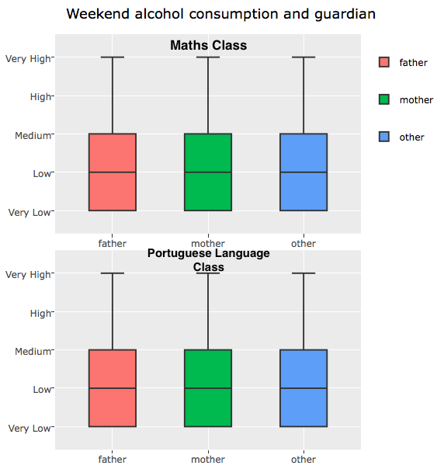

### Weekend Alcohol Consumption based on Gender

It can be easily seen from the two plots below that boys are drinking more than girls on weekends and girls highest is medium consumption level and on average low and for boys it high and on average it medium consumption level which shows boys are more prone hazards and are consuming a lot of alcohol.

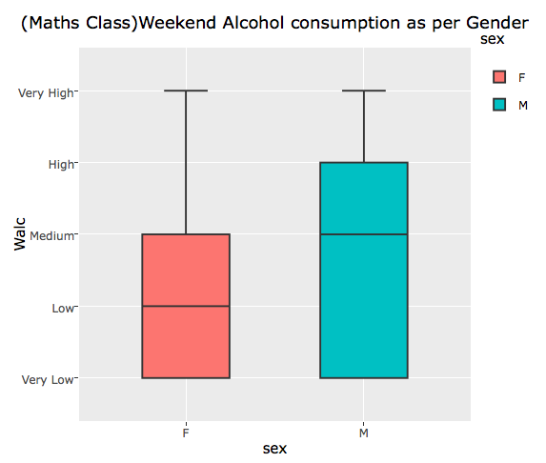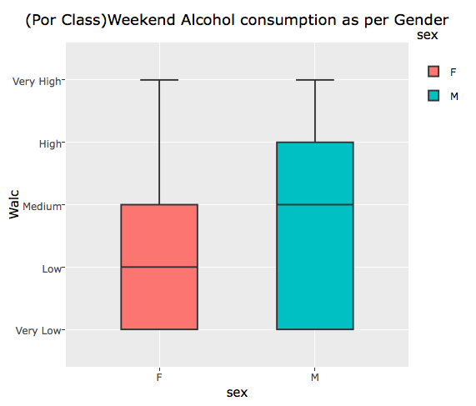

### Weekend Alcohol based on age

It can be seen in the results of both datasets that students of 20 years of age are consuming the highest level of alcohol compared to all students of other age.

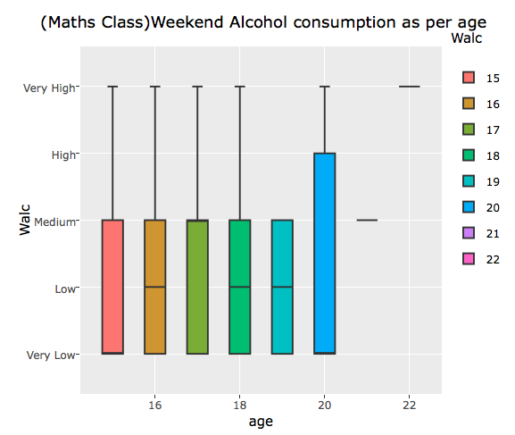

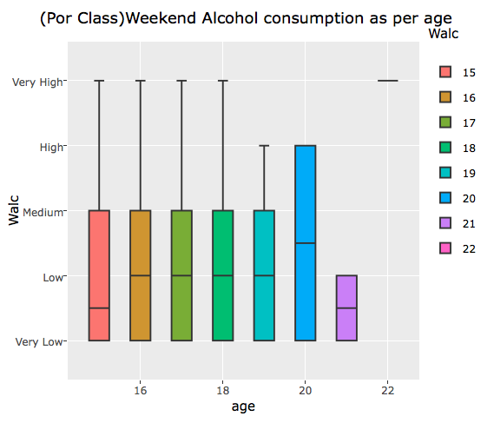

### Workday Alcohol Consumption

On workday the alcohol consumption of the majority is very low but still there are traces of medium and high consumption are found instead there should be no consumption at all as alcohol can ruin the life of these student.

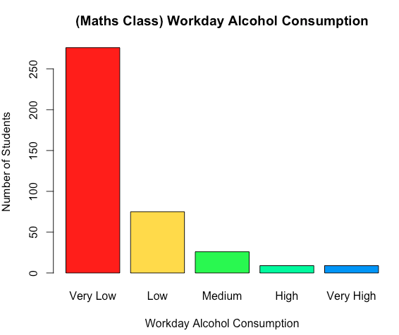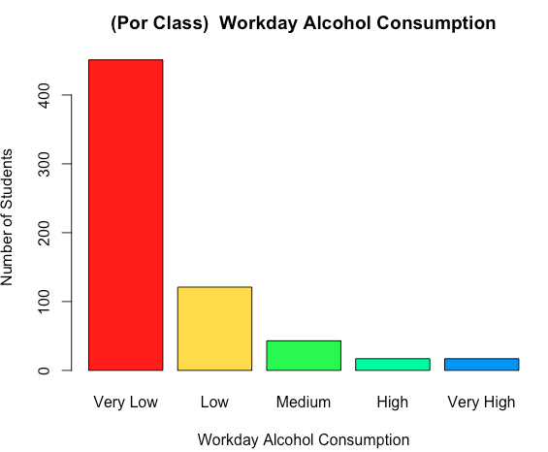

### School Absences and Alcohol consumption

Getting absent in school can negatively impact students studies

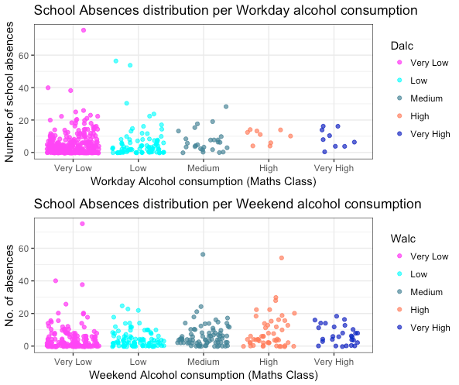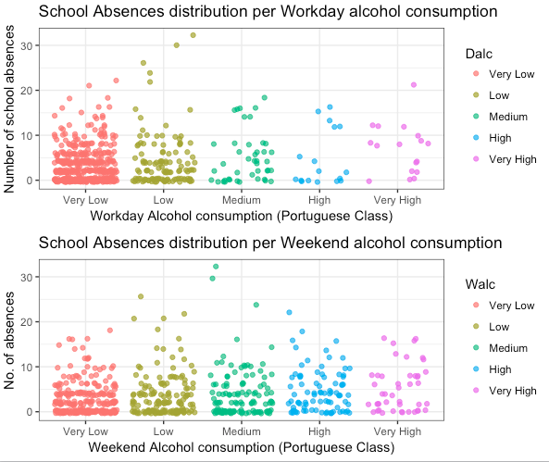

### Weekend Alcohol Consumption based on gender (sex)

Majority of students are in very low consumption but In the plots it can be seen the very high level of alcohol consumption is done mainly by boys on weekends and there’s also instance found many boys are consuming high level of alcohol on workdays which will have direct impact on their studies and the graphs below shows there is a good need for good direction for students of both schools.

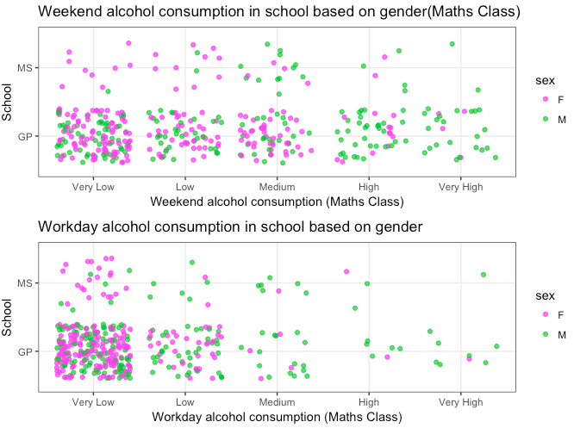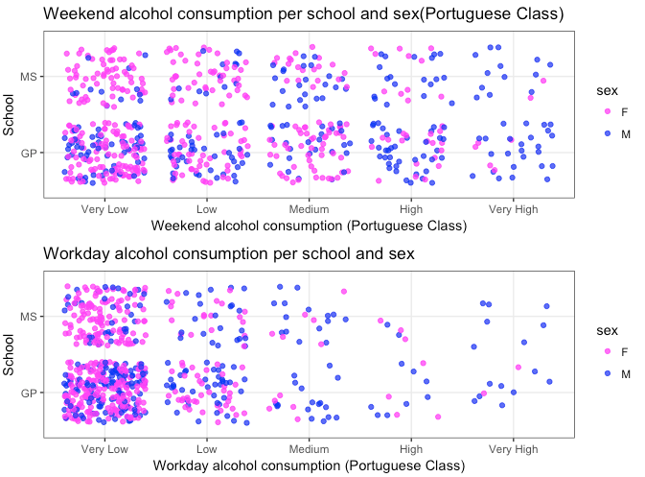

### Workday Alcohol Consumption and Grades

From the plot below it can be seen how alcohol has an impact on grades. The students consuming no alcohol / very low have better grades in all G1, G2, G3 and for both datasets

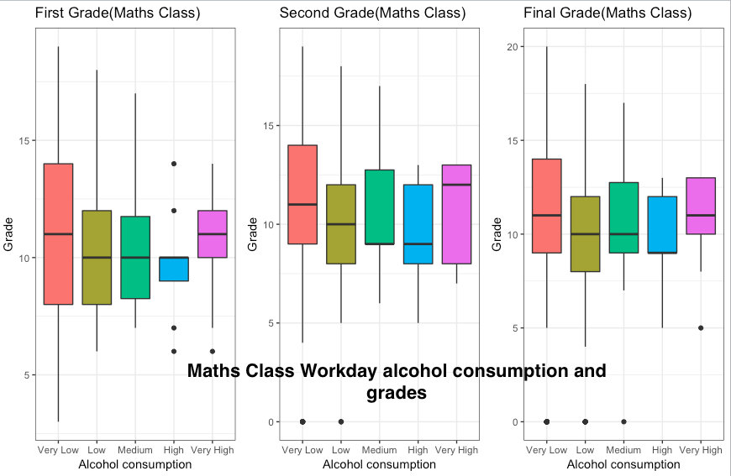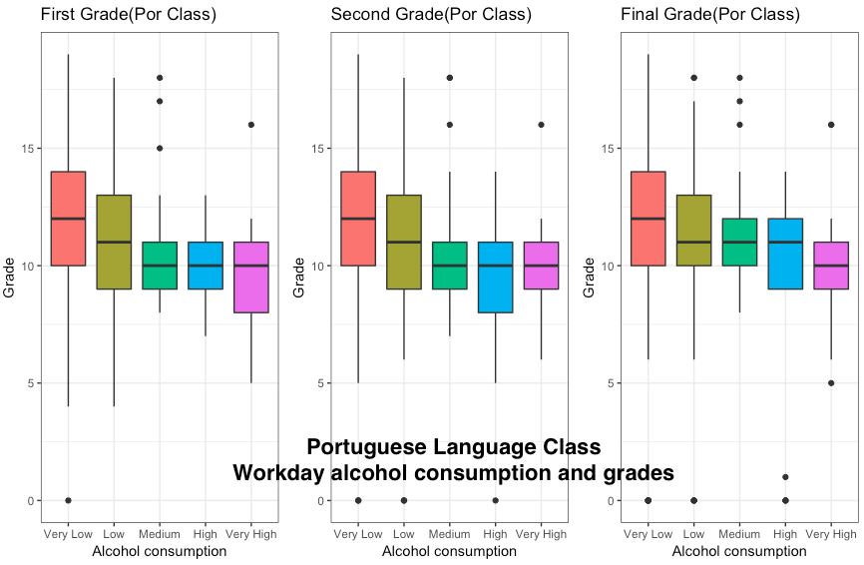

### Weekly Study Time

The histograms below show weekly study time of student in both dataset (on average its 2 -5 hours) more hours of study will result in better grades as we can see in plots below. So, the students should be suggested to study more and take part in activities and avoid alcohol

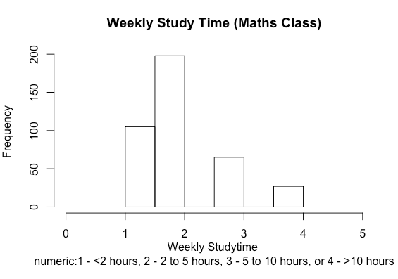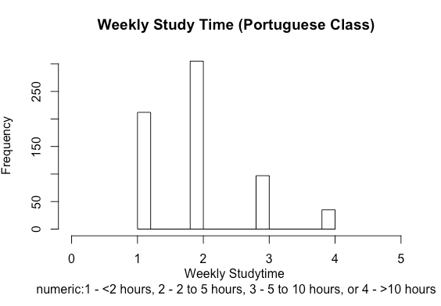

Better grades achieved by students when the weekly study hours are higher (for both datasets)

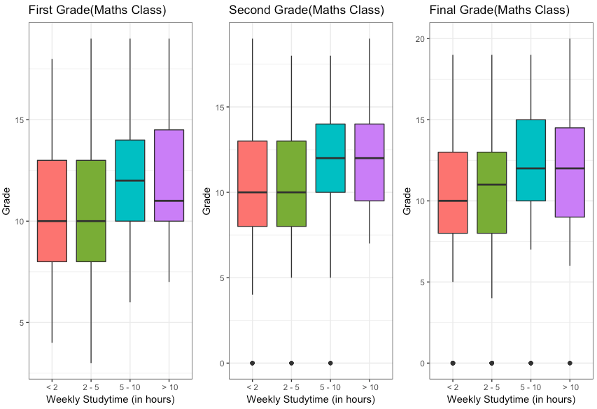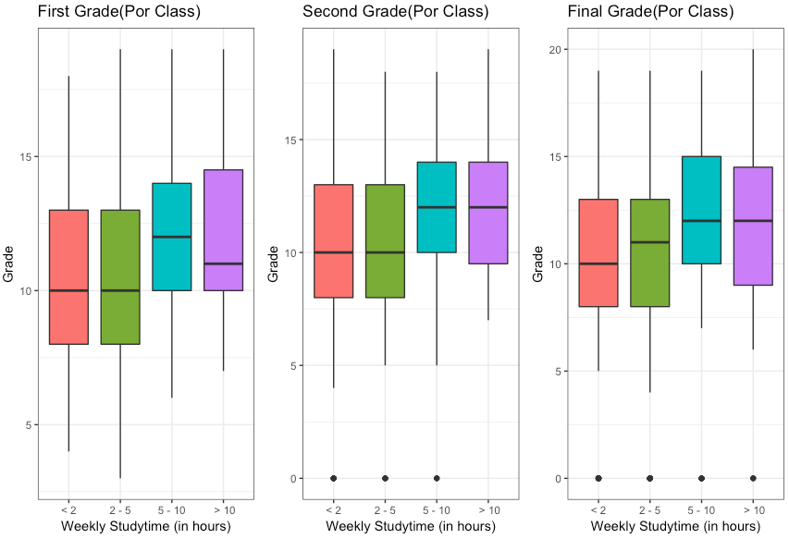

## Combined Analysis (Results)

